

California’s Ultimate

Pre-License Real Estate

Exam-Passing Workbook

Fourteen video lectures and workbook lessons

to easily follow and understand

1.



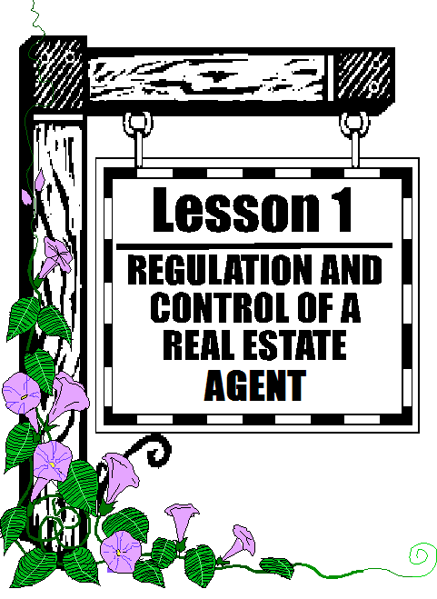

2.

Each lecture is followed by a workbook quiz

14 interactive quizzes following each lecture available at lumbleau.com

Practice state exams



3.

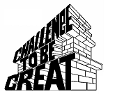

4.

Motivation - Essential for starting a successful real estate career